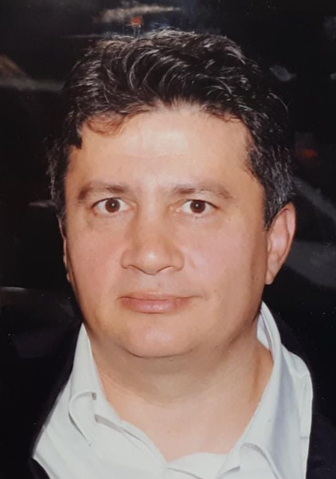
Nidai Kandemir

 | Pazartesi  Monday | Salı  Tuesday | Çarşamba  Wednesday | Perşembe  Thursday | Cuma  Friday | Cumartesi  Saturday
09:00 – 9:50 |  | CIV461 | TCE461 | ÖOS  Office Hour | ÖOS  Office Hour
10:00 – 10:50 | AOS | CIV461 | TCE461 | INT145  IMULAB | AOS
11:00 – 11:50 | AOS | INT121  IMULAB |  | INT245  IMULAB | AOS
12:00 – 12:50 | INT122  IMULAB | ÖOS  Office Hour | AOS |  | AOS
13:00 – 13:50 | INT122  IMULAB | AOS | AOS
14:00 – 14:50 | AOS | INT122  IMULAB | INT245  IMULAB
15:00 – 15:50 | ÖOS  Office Hour | AOS | INT245  IMULAB
 | TCE382  FE1-D1 |  | CE362/ HK3D01 |  | ÖOS  Office Hour
16:00 – 16:50 | INT145  IMULAB |  | ÖOS  Office Hour
17:00 – 17:50 | INT145  IMULAB
18:00 – 18:50
ÖOS: Student office hour
E-mail: nidai.kandemir@neu.edu.tr AOS: Office hour for research and administrative work
Nidai Kandemir

